This level is meant to say to the user – “look, you had those fancy functions, but that’s how life would be if we’d only taken one of them away from you”. As it was outlined in earlier levels, programming a lot about using correct functions and algorithms. Thus, this level intends further extend this point, but showing computing without fucntions that quicken your life.

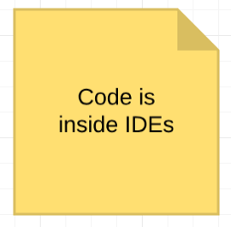As soon as you start computing, you will be introduced to IDEs – Integrated Development Environments*. See Figure 1 for further reference.* These are text editors that programmers use. For example, in order to create a game for iOS you will need to acknowledge Apple’s programming language, Swift, and IDE, which is Xcode. Not all programming languages have ‘fancy’ IDEs. By contrast, you may start using very basic, native text editor and console; and as you proceed to younger languages, you will discover Xcode and Android Studio. These IDEs allow you to use pre-installed pages, objects and many more features that save your time.

Figure 1: IDEs

To conclude, when you just start with a new language, spend some time on discovering IDEs that are most convenient and attractive for you. Not only this make computing comfortable, but also saves time. And time is money!